Selected Flowcharts

1.0 WinProc function flowchart
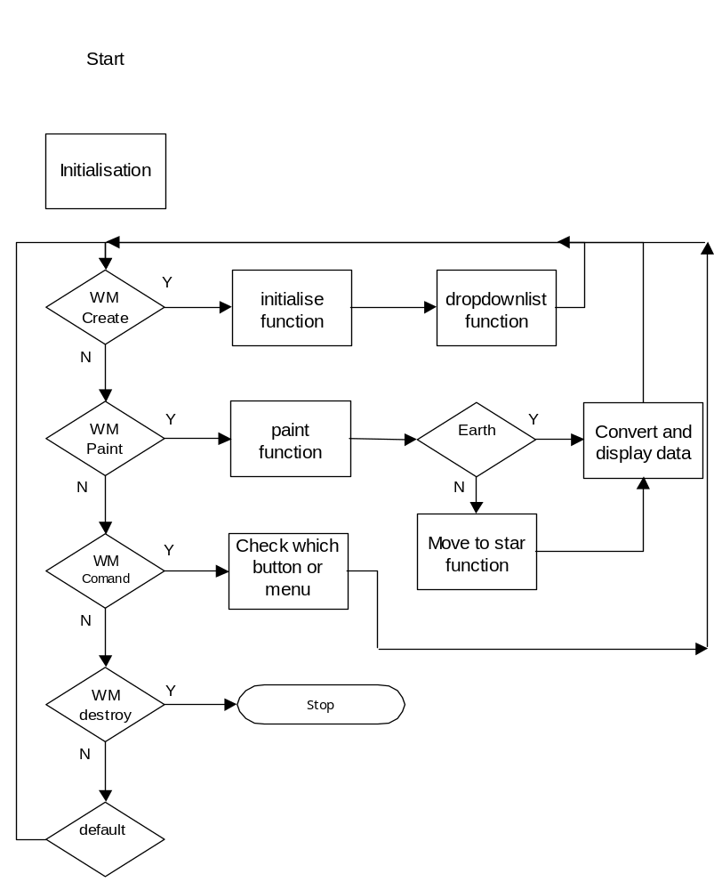

2.0 WM_COMMAND flowchart

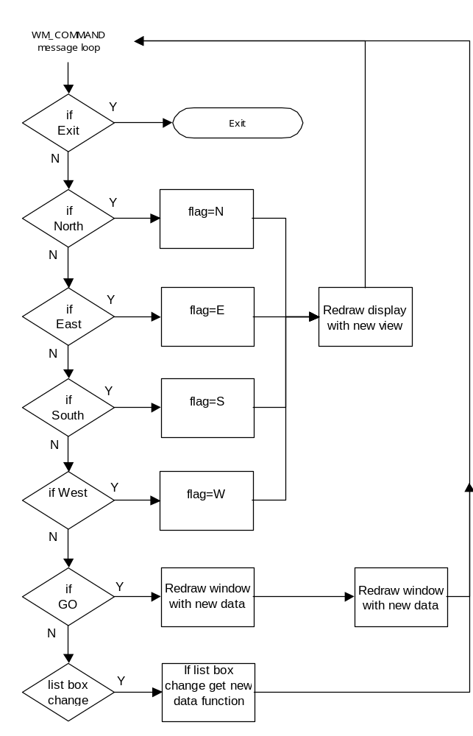

3.0 display_data function flowchart
